Contents

Introduction 2

Navigation Bar 3

Upload Files 4

Search Files 5

Sort Files 5

Edit Text Files 6

Right Click Menu 7

Folder 7

File 7

# Introduction

This is a guide to instruct users on how to get the best out of the RAPid Drive. RAPid Driveis a core application on the RAPid platform:

* It is easy to store, organise, find and share documentation within a client, all from one centralised placed – the RAPid platform.
* It can be used as a standalone feature for storing files of any type.
* It can be used in conjunction with Contract Management for storing contractual documents and other files.
* It can be used in conjunction with QlikView Manager for uploading and updating data files.
* It can be used in conjunction with the Self Service Data Uploader for uploading and updating data files.

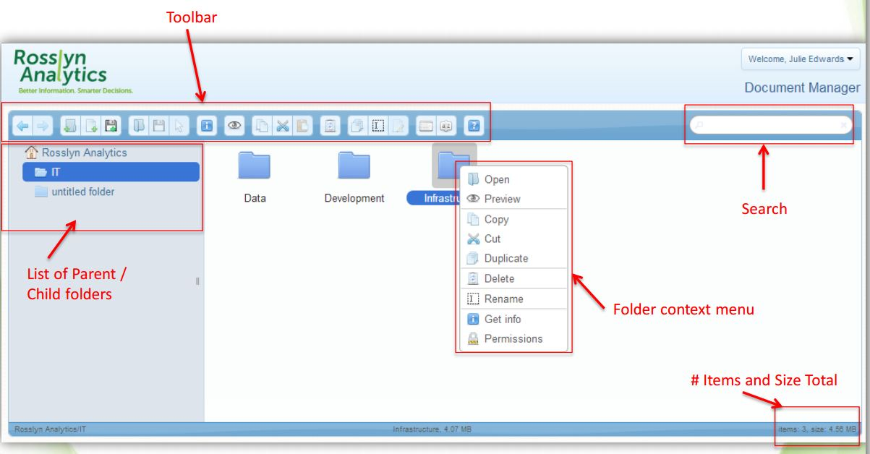

# Navigation Bar



1. Navigation: Use these arrows to go back and forward through the RAPid Drive.
2. Add a new folder.
3. Add a new text file.
4. Upload a file from a computer.
5. Open Folder.
6. Download to computer.
7. Select files.
8. Get info: Path in RAPid Drive and current permission settings.
9. Preview File: Name of file, file type (e.g. PDF file), size of file and information on when the file was last modified locally.
10. Copy file or folder.
11. Cut file or folder.
12. Paste file or folder.
13. Delete file or folder.
14. Duplicate file or folder.
15. Rename file or folder.
16. Edit text file.
17. List or icons view.
18. Sort folder and files.

# Default

By default, there is an upload limit of 1GB per file. To increase this limit please contact support@rosslynanalytics.com

# Upload Files

Click on the Home Folder.

Click in the Folder button to create a new folder.

Name the new folder.

Drag and drop files to upload documents from a computer or click on the upload icon to open an upload window.**.**

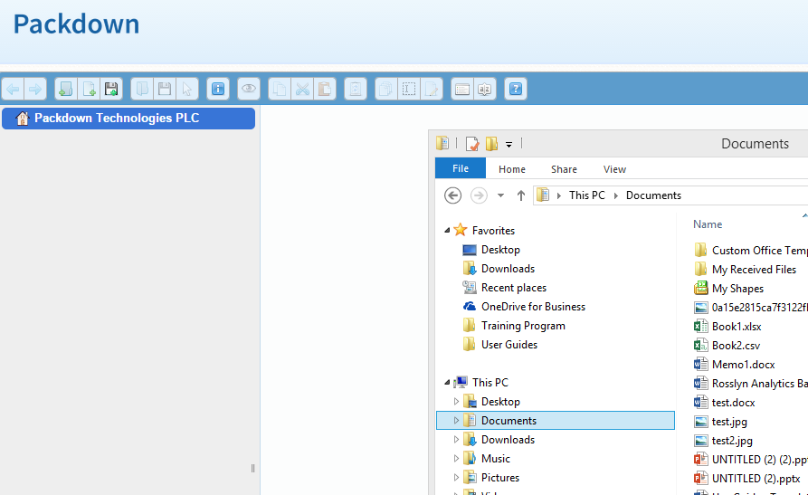

Click on the icon to preview files. Online preview includes the file type, file size, date of when it was last modified.

Download file to view and edit file offline.

# Search Files

The Search Boxis located on the top right corner of the home page.

* The search feature searches by the name of a file and folder.
* It does not search the content of individual files.
* The search feature is based on the permission access levels. So if the file does not come up in a search, the user may have no access to the file.

# Sort Files

Document centre allows users to sort documents and files by clicking on the sort icon on the navigation panel. These are the following sort options:

* By name
* By size
* By Kind (type of document e.g. PDF, or text file)
* By date
* Sort Folders first (folders listed before files)

# Text Files

Any file saved with the suffix ‘.txt’ can be opened, edited and saved from within inside the RAPid Drive.

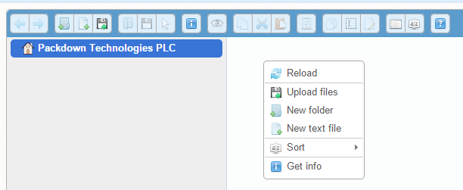Right click in the file space and select ‘New Text File’.

Name the file.

Right click on the file.

Select Edit File. Edit as required and then click ‘Save’.

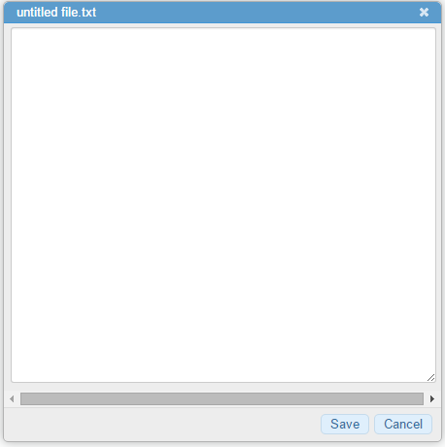

# Right Click Menu

## Folder

By right clicking on any folder the below will appear. The following options are as explained above for the selected folder. The permissions option is only available for Client Administrators.

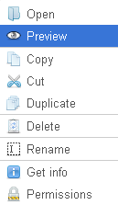

## File

By right clicking on any folder the below will appear. The following options are as explained above for the selected file. The permissions option is only available for Client Administrators.

